EXPERIMENT 9
CREATE TABLE BANK_26 (
bankcode VARCHAR(5)PRIMARY KEY,
bankname VARCHAR(50) NOT NULL,
headoffice VARCHAR(50),
branches INT CHECK(branches > 0)
);
INSERT INTO BANK_26 VALUES('KGB','Kerala Gramin Bank','Kochi',12);
INSERT INTO BANK_26 VALUES('SBI','South Bank of India','Mumbai',101);
INSERT INTO BANK_26 VALUES('SIB','South Indian Bank','Chennai',67);
INSERT INTO BANK_26 VALUES('HDF','HDFC Bank','Kottayam',47);
INSERT INTO BANK_26 VALUES('ICI','ICIC Bank','Ernakulam',36);

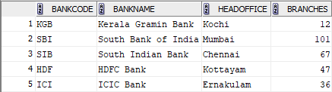

CREATE TABLE BRANCH (
branchid INT PRIMARY KEY,
branchname VARCHAR(50) DEFAULT 'New Delhi',
bankid VARCHAR(5),
FOREIGN KEY (bankid) REFERENCES BANK_26(bankcode)
);

INSERT INTO BRANCH VALUES(100,'Mevada','SIB');
INSERT INTO BRANCH VALUES(102,'Kozhuvanal','SBI');
INSERT INTO BRANCH VALUES(104,'Pala','ICI');
INSERT INTO BRANCH VALUES(106,'Kottayam','HDF');
INSERT INTO BRANCH VALUES(108,'Chennai','KGB');
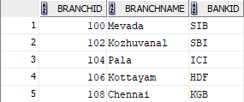

I) Create a View named bank_head office to hold the details of all bank whose head
office at Ernakulam.
CREATE VIEW bank_head_office AS
SELECT *
FROM BANK_26
WHERE headoffice = 'Ernakulam';
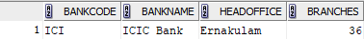
II) Create a View named bank_branch to hold the details of all bank who have branches
at kottayam.
CREATE VIEW bank_branch AS
SELECT B.*
FROM BANK_26 B
JOIN BRANCHES BR ON B.bankcode = BR.bankid
WHERE BR.branchname = 'Kottayam';
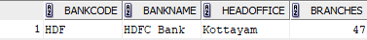
III) Create a View to show banks with more than 50 branches
CREATE VIEW banks_more_than_50 AS
SELECT *
FROM BANK_26
WHERE branches > 50;
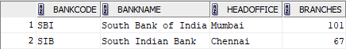
IV) Create a View to display bank name and branch name
CREATE VIEW bank_branch_details AS
SELECT B.bankname, BR.branchname
FROM BANK_26 B
JOIN BRANCHES BR ON B.bankcode = BR.bankid;
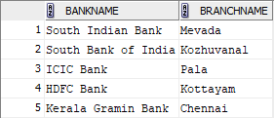
V) Create a View to show banks located outside Ernakulam
CREATE VIEW banks_outside_ernakulam AS
SELECT *
FROM BANK_26
WHERE headoffice <> 'Ernakulam';
